Courtney Daniels

Veteran Medical Access Map

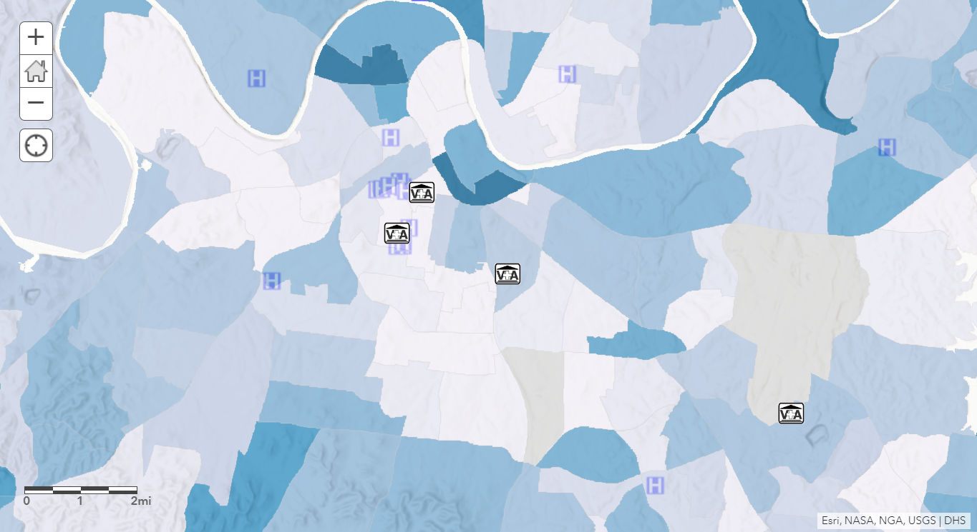

Legend:

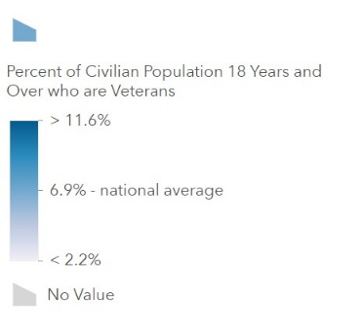

This map displays the proximity of U.S. veteran populations to private medical care facilities compared to the proximity of those populations to Veteran-specific medical centers in the city of Nashville. The map legend uses darker hues of blue to represent concentrations of veterans that exceed a national average of 6.9 percent of census respondents. The highest concentrations show areas with a veteran demographic of 11.6 percent or greater. The northernmost neighborhoods of metro Nashville seem to show a higher resident value than the areas to the immediate south and west. While there are four veteran hospitals or clinics in the local area, the map shows that the number of private hospitals exceed that number by ten with an average of seven private hospitals for every two hospitals operated by the Veterans Health Administration.

This combined information can play an instrumental role in not only helping veterans to determine accessibility to healthcare but can be used to influence policymakers in providing efficient care for the medical needs of Nashville-area veterans. This topic has a particular relevance since the passing of the Veterans Access, Choice, and Accountability Act in 2014, popularly known as the Veteran’s Choice Program. Due to feedback from veterans who live outside the ranges of reasonable travel infrastructure, the U.S. Congress determined that veterans could begin receiving care at private hospitals if it would be more reasonable for their accommodation. Since the passing of this legislation, the topic of veteran accessibility to private healthcare has remained at the forefront of policymaking for the Veterans Health Administration.

I chose this map combination as a veteran who has lived in the Nashville area. One prevalent issue for Nashville-are veterans is how the rapid population growth of the city affects logistical factors like traffic and medical accessibility. These are multifaceted issues that might require local, state, and federal cooperation to solve, as well as input from area veterans. In making the map I was able to visually recognize the occurrence of overlapping private medical infrastructure with that of federal hospitals. At least half of these facilities are located within a five-mile radius. This could very well predict that veterans outside of the immediate metro area will have to venture towards downtown for their healthcare needs as medical facilities outside of this radius are increasingly sparse.

Base Map:

“Tennessee Hospitals”, Sourced from Department of Homeland Security, Homeland Security Infrastructure Program (HSIP) (April 15, 2014)

Map Layer 1: ACS Veteran Status Variables (Oct 23, 2018)

Census Bureau/American Community Survey (Veteran Map)

Map Layer 2: “Veterans Health Administration Medical Facilities” (Jun 13, 2017)

Sourced from Veteran’s Health Administration